Full Stack Programming Lab
BSSE-VI-B & A
Lab_13
API RESTful Deployment and Testing
Lab
Instructor:
Mr. Sharif Hussain

Lab Title: API RESTful Deployment and Testing Lab

Contents
1. Lab Objectives 2
2. Short explanations: 3
3. Project Setup for RESTful API Development and Testing 3
4. Postman Test: 11
5. Browser Testing: 13
6. Lab Task Instructions: 16
7. Lab Tasks: - 18
7.1. Task 1: 18

Lab Objectives
After completing this lab, students will be able to design, develop, deploy, and test RESTful APIs for a dynamic web application using modern full-stack technologies, including Next.js, Node.js, Express.js, and MongoDB. They will also gain practical experience in API integration, backend development, and testing workflows.
Software Required
- Node.js (LTS Version)
- MongoDB Compass
- Visual Studio Code
- Postman
- Web Browser (Google Chrome / Microsoft Edge / Firefox etc.)

Short explanations:
- RESTful API: A web service that enables client-server communication using HTTP methods like GET, POST, PUT, and DELETE.
- Node.js (LTS): A JavaScript runtime used to build scalable backend applications
https://nodejs.org
- MongoDB Compass: A GUI tool for managing and visualizing MongoDB databases
https://www.mongodb.com/products/compass
- Visual Studio Code: A lightweight code editor for writing and managing code
https://code.visualstudio.com
- Postman: A tool for testing APIs by sending requests and viewing responses
https://www.postman.com/downloads
- Web Browsers: Software to access web apps
(Chrome — https://www.google.com/chrome, Edge — https://www.microsoft.com/edge, Firefox — https://www.mozilla.org/firefox)

Project Setup for RESTful API Development and Testing
mkdir mern-patient-api
cd mern-patient-api
- Backend Setup (Node + Express + MongoDB)
  - cd mern-patient-api
  - mkdir backend
  - cd backend
  - npm init –y
Install dependencies:
  - npm install express mongoose cors dotenv nodemon
  - express → Web framework
  - mongoose → MongoDB ODM
  - cors → Cross-origin access
  - dotenv → Environment variables
  - nodemon → Auto server restart
- Frontend (React.js Setup)
  - npx create-react-app frontend
  - cd frontend
  - npm install axios
  - npm start
- Go to browser open URL:
  - http://localhost:5000/api/patients
- App frontend and Backend Structure
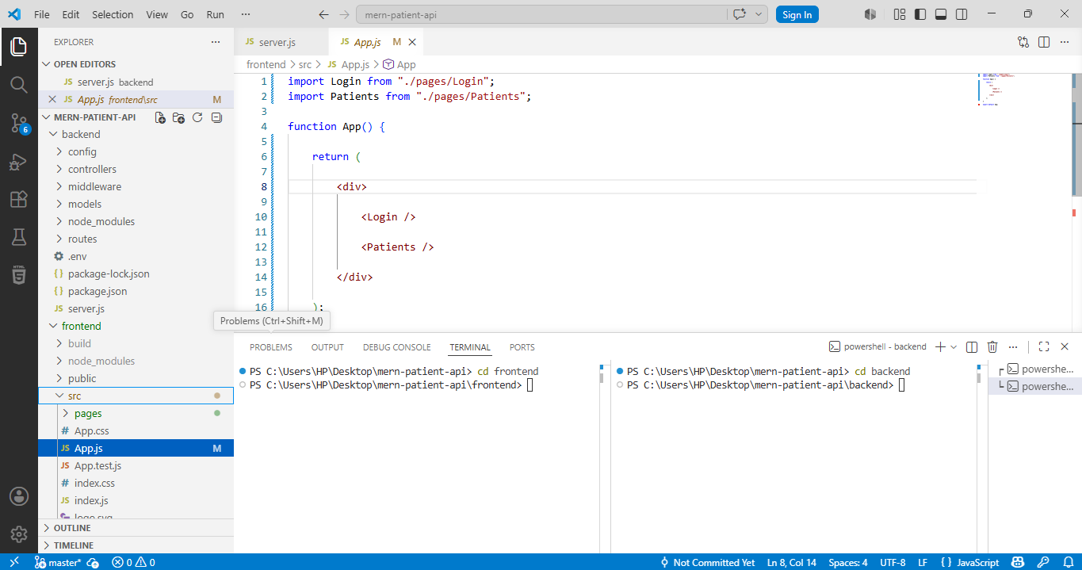

- Frontend (React.js Setup)
- server.js → Starts backend server and connects all parts
- Set app.js

const express = require("express");
const cors = require("cors");
require("dotenv").config();

const connectDB = require("./config/db");

const app = express();

/* Middleware */
app.use(cors({
origin: "http://localhost:3000",
credentials: true
}));

app.use(express.json());

/* Database Connection */
connectDB();

/* Routes */
const authRoutes = require("./routes/authRoutes");
const patientRoutes = require("./routes/patientRoutes");

app.use("/api/auth", authRoutes);
app.use("/api/patients", patientRoutes);

/* Server */
const PORT = process.env.PORT || 5000;

app.listen(PORT, () => {
console.log(`Server running on port ${PORT}`);
});
- Now start sever
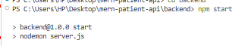

- config/ → Stores configuration files (DB, settings, keys)
- config/db.js → Handles MongoDB database connection

// config/db.js
const mongoose = require("mongoose");
const connectDB = async () => {
try {
await mongoose.connect(process.env.MONGO_URI);
console.log("MongoDB connected");
} catch (error) {
console.log("MongoDB connection error:", error);
process.exit(1);
}
};
module.exports = connectDB;
.env
port = 5000
MONGO_URI=mongodb://127.0.0.1:27017/patientsDB
JWT_SECRET=mySecretKey123

- models/ → Defines database structure (schemas)

User.js
const mongoose = require("mongoose");
const userSchema = new mongoose.Schema({
username: String,
password: String,
role: {
type: String,
default: "user"
}
});
module.exports = mongoose.model("User", userSchema);
Patient.js
const mongoose = require("mongoose");
const patientSchema = new mongoose.Schema({
name: String,
age: Number,
disease: String,
contact: String
});
module.exports = mongoose.model("Patient",patientSchema);

- routes/ → Defines API endpoints (URLs)

authRoutes.js
const express = require("express");
const router = express.Router();

const bcrypt = require("bcryptjs");
const jwt = require("jsonwebtoken");

const User = require("../models/User");
const auth = require("../middleware/authMiddleware");

/* REGISTER USER */
router.post("/register", async (req, res) => {
const { username, password, role } = req.body;
const hashedPassword =
await bcrypt.hash(password, 10);
const user = await User.create({
username,
password: hashedPassword,
role
});
res.json({
message: "User registered",
user
});
});

/* LOGIN USER */
router.post("/login", async (req, res) => {
const { username, password } = req.body;
const user = await User.findOne({ username });
if (!user) {
return res.status(404).json({
message: "User not found"
});
}
const isMatch =
await bcrypt.compare(password, user.password);

if (!isMatch) {
return res.status(400).json({
message: "Wrong password"
});
}

const token = jwt.sign(
{
id: user._id,
role: user.role
},
process.env.JWT_SECRET,
{
expiresIn: "15m"
}
);

res.json({
accessToken: token
});

});

/* 🔐 GET ALL USERS (ADMIN ONLY) */
router.get("/users", auth("admin"), async (req, res) => {

const users = await User.find().select("-password");

res.json(users);

});
module.exports = router;

patientRoutes.js
const express = require("express");
const router = express.Router();

const auth =
require("../middleware/authMiddleware");

const controller =
require("../controllers/patientController");

/* CREATE */
router.post(
"/",
auth("admin"),
controller.createPatient
);

/* GET ALL */
router.get(
"/",
auth(),
controller.getPatients
);

/* GET ONE */
router.get(
"/:id",
auth(),
controller.getPatient
);

/* UPDATE */
router.put(
"/:id",
auth("admin"),
controller.updatePatient
);

/* DELETE */
router.delete(
"/:id",
auth("admin"),
controller.deletePatient
);
module.exports = router;

- controllers/ → Contains logic for API actions (CRUD operations)

patientController.js
const Patient =
require("../models/Patient");

/* CREATE */
exports.createPatient =
async (req, res) => {

const patient =
await Patient.create(req.body);

res.json(patient);

};

/* GET ALL */
exports.getPatients =
async (req, res) => {

const patients =
await Patient.find();

res.json(patients);

};

/* GET ONE */
exports.getPatient =
async (req, res) => {
const patient =
await Patient.findById(
req.params.id
);
res.json(patient);
};

/* UPDATE */
exports.updatePatient =
async (req, res) => {

const patient =
await Patient.findByIdAndUpdate(
req.params.id,
req.body,
{ new: true }
);

res.json(patient);

};

/* DELETE */
exports.deletePatient =
async (req, res) => {

await Patient.findByIdAndDelete(
req.params.id
);

res.json({
message: "Patient deleted"
});

};

- Frontend Setup
- Set app.js
import Login from "./pages/Login";
import Patients from "./pages/Patients";
function App() {
return (
<div>
<Login />
<Patients />
</div>
);
}
export default App;

Postman Test:
- Start frontend and Backend Both
  - Npm start
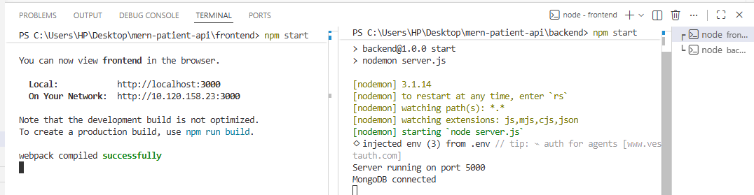

- Register
- Select POST: and body as in picture
http://localhost:5000/api/auth/register

- Admin
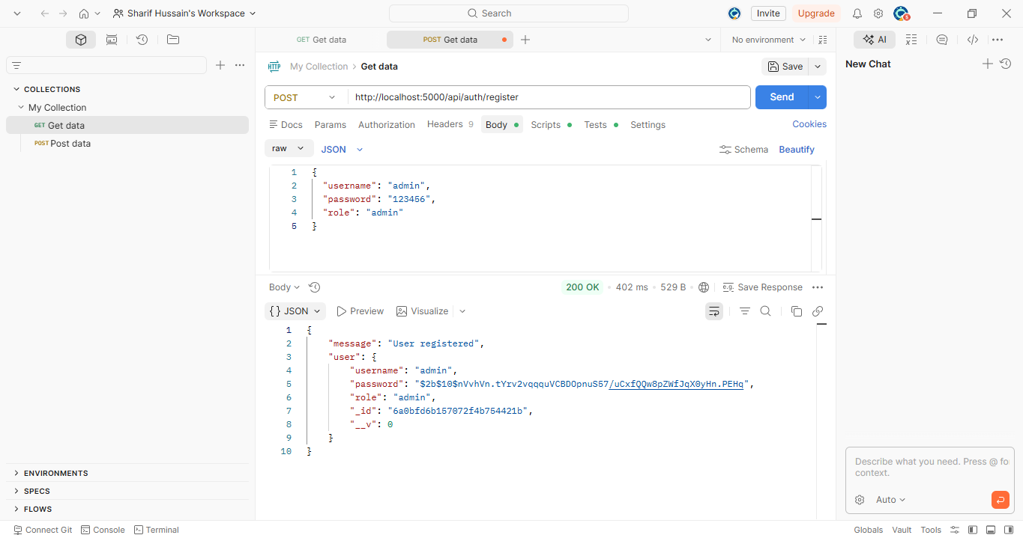
- User login
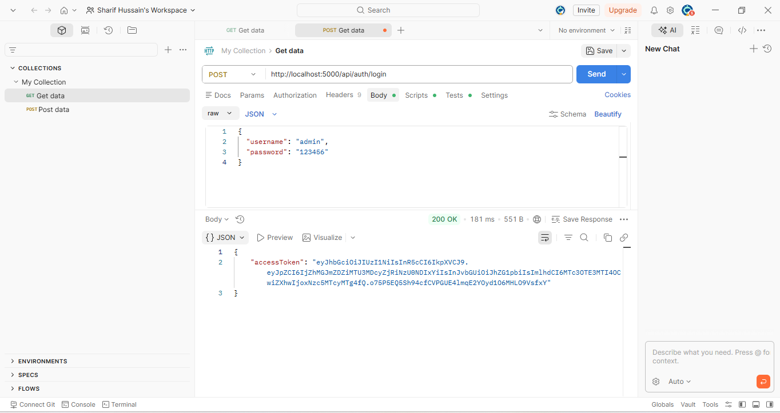
- Users List
- Get : http://localhost:5000/api/auth/users
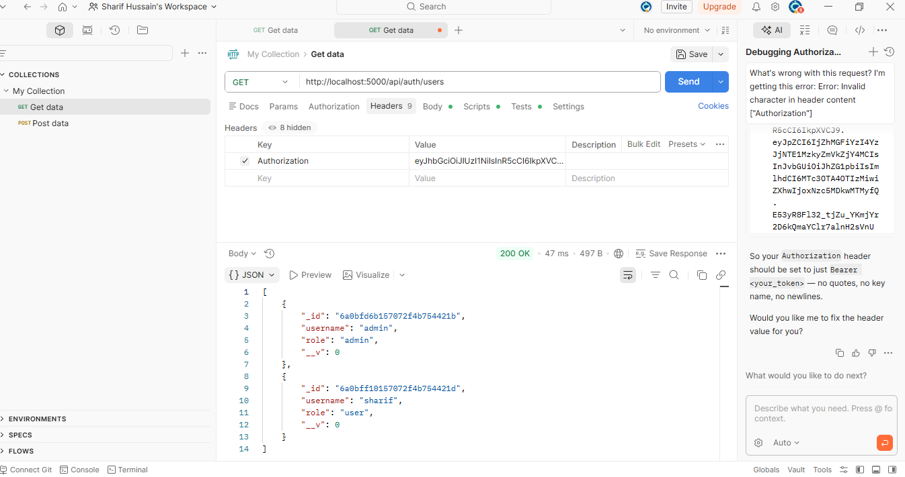

- Add patients:
Post : http://localhost:5000/api/patients
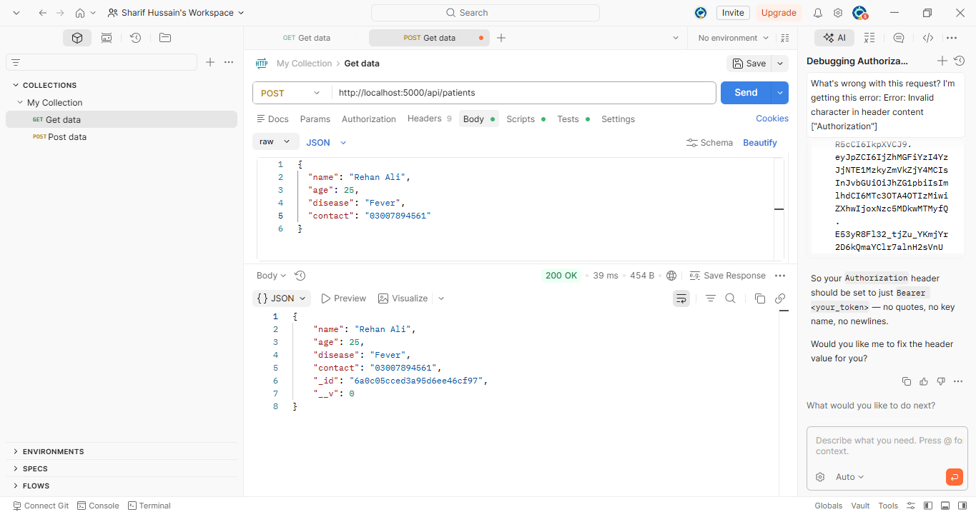
Get patients: http://localhost:5000/api/patients
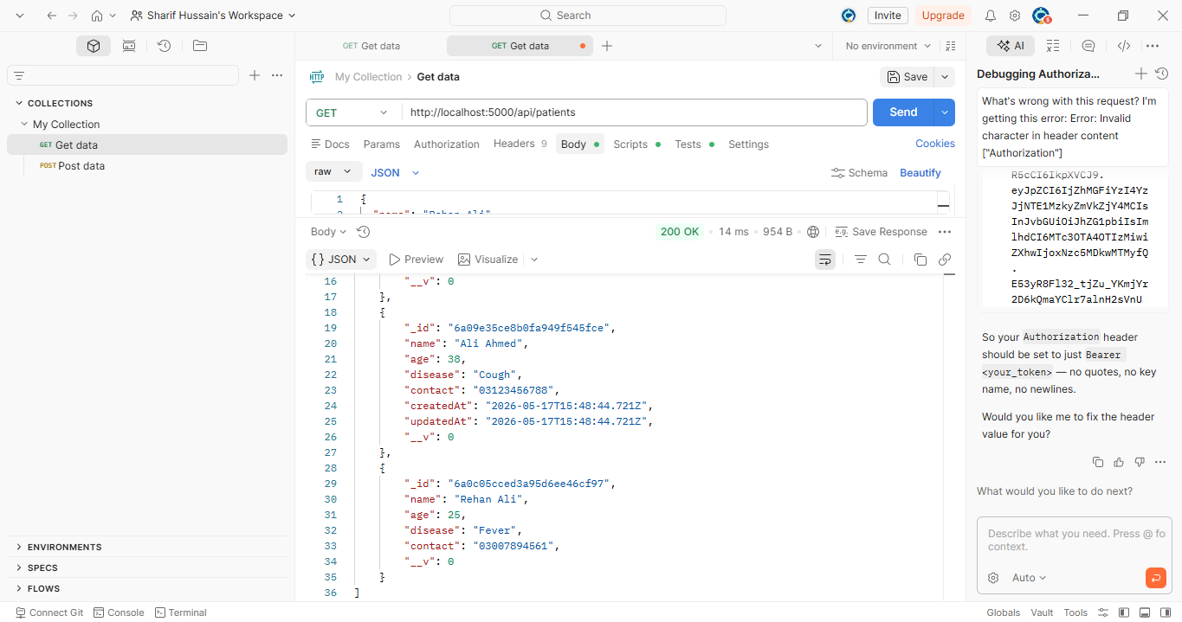

- PUT http://localhost:5000/api/patients/:id
- Update patient by ID

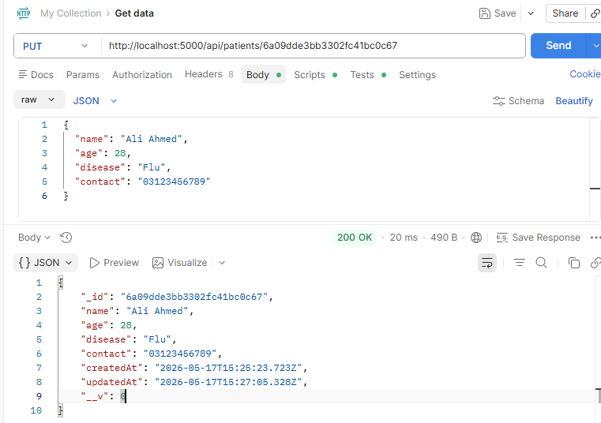
DELETE http://localhost:5000/api/patients/:id
Delete patient by ID
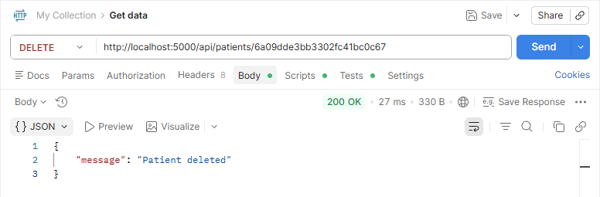

Browser Testing:
- Login as admin:
- http://localhost:3000/login

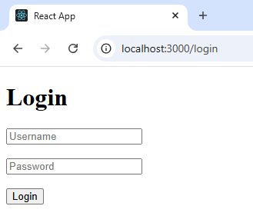
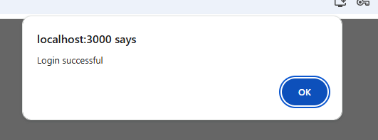
Get: http://localhost:3000/patients
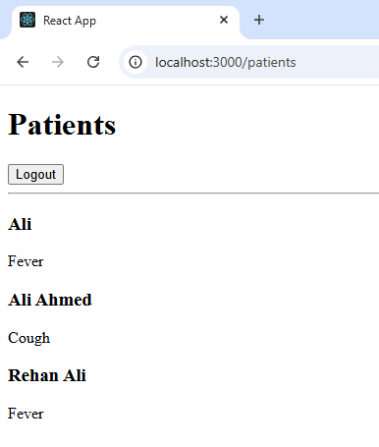
import axios from "axios";
import {
useEffect,
useState
} from "react";
import { useNavigate }
from "react-router-dom";
function Patients() {
const navigate = useNavigate();
const [patients, setPatients] =
useState([]);
/* GET PATIENTS */
useEffect(() => {
axios.get(
"http://localhost:5000/api/patients",
{
headers: {
Authorization:
localStorage.getItem(
"accessToken"
)
}
}
)
.then((res) => {
setPatients(res.data);
})
.catch(() => {
alert("Unauthorized");
});
}, []);
/* LOGOUT */
const logout = () => {
localStorage.removeItem(
"accessToken"
);
navigate("/login");
};
return (
<div>
<h1>Patients</h1>
<button onClick={logout}>
Logout
</button>
<hr />
{
patients.map((p) => (
<div key={p._id}>
<h3>{p.name}</h3>
<p>{p.disease}</p>
</div>
))
}
</div>
);
}
export default Patients;

Lab Task Instructions:
- Create a GitHub account if you do not already have one.
- Create a repository named Full-Stack-Programming-Lab.
- Add me as a collaborator using the following email address: sharifali.aulecturer@gmail.com
- Clone the repository to your local machine.
- Inside the repository, create a new folder named
lab_13_api_restful_deployment_and_testing_lab
- Push your completed work to GitHub.
- Prepare a Word or PDF document and include the following:
  - Screenshots of the output/results
  - Your GitHub repository URL
  - Upload the Word/PDF file to GCR for submission

Lab Tasks: -

Task Lab Weather Forecast API (Real City-Based System)
Design and develop a REST API using Node.js and Express.js that integrates with an external weather service to provide real-time weather information for different cities.
Task Requirements:
- Create a REST API endpoint that accepts a city name as a parameter
- Connect your API with a third-party weather service (e.g., OpenWeather API)
https://openweathermap.org/api
- Return weather information in JSON format
The response must include:
- City name
- Current temperature
- Weather condition (e.g., cloudy, sunny, rain)
- Humidity level
Handle errors properly (e.g., invalid city name or API failure)
Test your API using Postman or browser
- It should be able to fetch live weather data for any valid city through their custom API endpoint.

LAB 02: News Headlines API using External Service
To develop a RESTful API using Node.js and Express.js that fetches and displays the latest news headlines using a third-party news service.
- Work with external REST APIs (https://newsapi.org/ )
- Handle dynamic route parameters
- Process and filter API responses
- Build structured JSON responses
- Implement error handling in backend applications
Design and implement a REST API that retrieves the latest news headlines for a given country using an external news API service.
Requirements
- Accept country code as a URL parameter
- Connect with a third-party news API service
- Fetch latest top headlines
- Return structured JSON format
- Include: News Title, Source Name, News URL, Publication Date
- Limit response to 5–10 articles
- Handle API errors and invalid inputs
Test using Postman and browser
- A working REST API that provides real-time top headlines for a selected country.

✨🌟 Best of Luck 🌟✨

